LAB # 14
AGGREGATION IN MONGODB

Objectives :

• To understand the concept of Aggregation in MongoDB.
• To learn and apply various Aggregation Pipeline stages

Lab Tasks :

1. Create a database named 'university' with a 'students' collection. Insert at least 8 student documents with fields: name, department, cgpa, semester, and courses (array).

Code
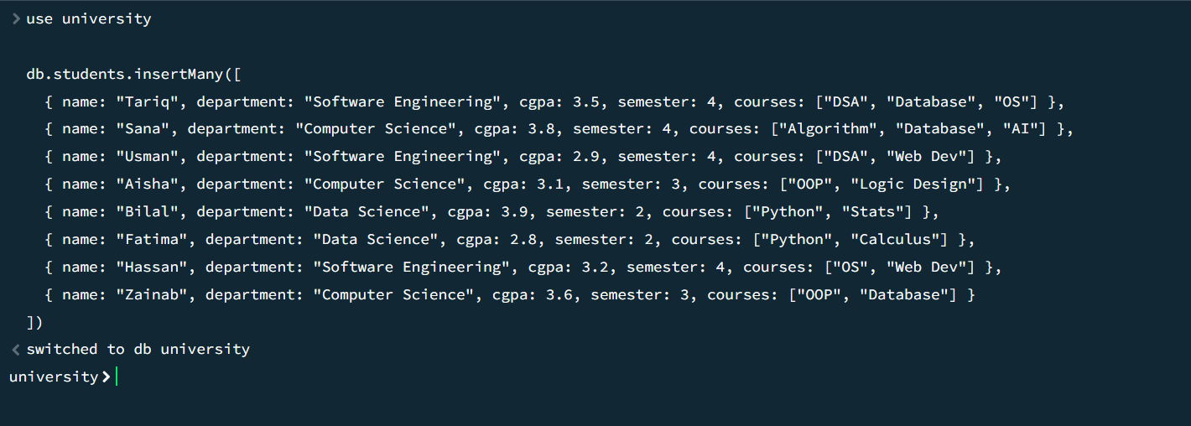
2. Use the $group stage to find the average CGPA per department.

Code
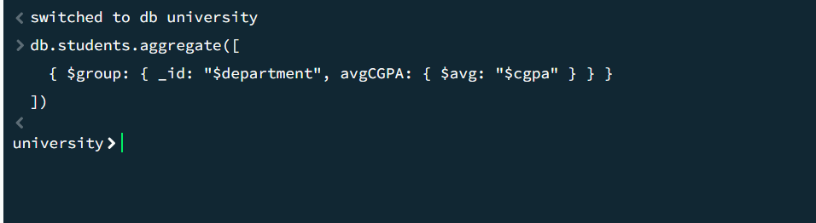

3. Use $match and $group to count how many students in each department have a CGPA greater than 3.0.

Code
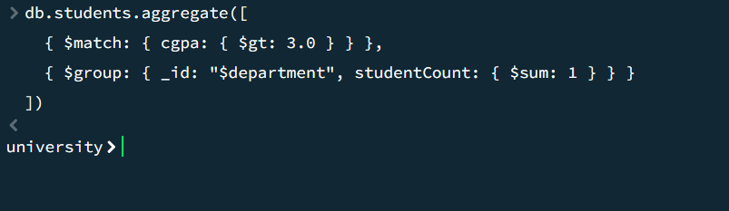

4. Use $unwind on the 'courses' array to list each course separately, then use $group to count how many students are enrolled in each course.

Code
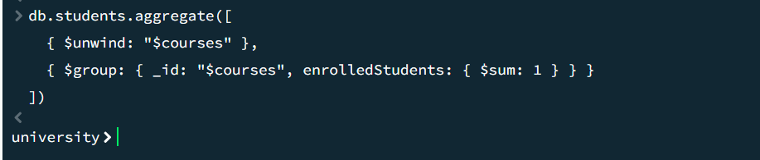
5. Use $sort and $limit to find the top 3 students with the highest CGPA.

Code
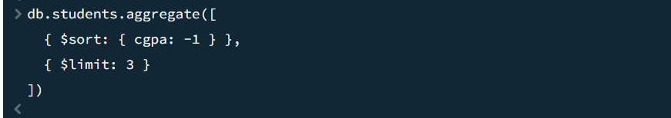
6. Use $project to display only the name and cgpa fields, renaming cgpa to 'GradePoint'.

Code
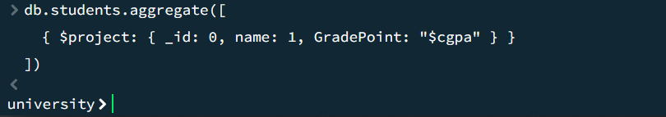
7. Create a second collection 'teachers' and use $lookup to join it with 'students' on the department field.

Code
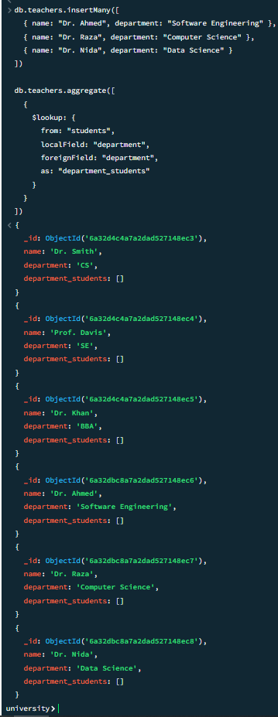

Reflection Questions:

1. What is the difference between aggregation and a simple find() query in MongoDB?

A simple find() query is used for basic data retrieval and filtering, returning documents exactly as they are structured in the database. Aggregation, however, is a pipeline framework that allows you to transform, compute, and reshape data. It can perform operations like calculating averages, grouping data by specific fields, unwinding arrays, and joining collections, returning computed results rather than just raw documents.

2. What was the most challenging part of this lab, and how did you overcome it

The most challenging part of this lab was understanding the syntax and logic for the $lookup stage to join two collections properly. Overcoming this required breaking down the pipeline to understand how the localField from the current collection maps to the foreignField in the target collection, and testing the output to see how the joined data is appended as a new array field.

